Viewing Brightspeed Online Listing Editor

V-COLE

Contents

V-COLE Introduction 2

Overview 2

Accessing VCOLE 2

V-COLE Listing Search 3

Listing Search 3

V-COLE Successful Search 4

Successful Search 4

Additional Listing Details 6

Viewing Additional Details 6

Additional information by name link 6

Additional information by style link 7

#### V-COLE Introduction

|  |  |
| --- | --- |
| Overview | V-COLE - Viewing Brightspeed Online Listing Editor is a database of all Brightspeed directory listings.  The purpose of this document is to define the steps to effectively use V-COLE |

|  |  |
| --- | --- |
| Accessing VCOLE | V-COLE is accessed by clicking the following link:  <https://cole.centurylink.com/clipsPL/>  or by typing the address in an Internet Explorer browser.  Once on the site, all users log in with the following information:   * **User Id** of **1000308** * **Password** of **Century1a** * Click **Login**   **Note:** Once in a V-COLE, if session expires, you may receive “invalid attempt” errors when signing back in. If errors occur, close completely out of the system and log back in. |

#### V-COLE Listing Search

|  |  |
| --- | --- |
| Listing Search | When the **V.C.O.L.E.** (Viewer) is displayed (after logging in):  • Enter the Product ID (phone number) in the Search Value field (* = required).  • You may search by account name or BAN as well by using the Option  drop-down menu.  • Other fields, Directory, State and Provider are optional, and are used to narrow the search.  • Click Search |

#### V-COLE Successful Search

|  |  |
| --- | --- |
| Successful Search | If the record is found by the search, the Listings Search Results are displayed.  **Example of successful Listing Search Results**  **Important** : If a searching a listing which is Non-Published (NP) or Non-List (NL), V-COLE may not display the telephone number or name (see the last listing in the screen print above).  The table below and on the next page provides the listing information that is displayed on a successful listing search.  **Note**: Hovering over the symbols with the cursor displays the status. |

|  |
| --- |
| **Listing Information Displayed** |

|  |  |
| --- | --- |
| **Indicator** | **Description** |
|  | Green box = Listed, Blue box = Non Listed, Red box = Non Published |
|  | House = Residential, Building = Business |
| Status | Green Phone = Active listing  Phone with Red X = Disconnected listing |
| Style | |  |  | | --- | --- | | “CI” | Caption Indent | | “SL” | Straight Line Listing | | “SH” | Straight Line Header (aka SLU) | | “SI” | Straight Line Indent (aka SLU Indent) | |

Continued on next page

, Continued

|  |
| --- |
| Listing Information Displayed (table continued) |

|  |  |
| --- | --- |
| **Indicator** | **Description** |
| Type | |  |  | | --- | --- | | “AL” | Additional Listing  **Note**: CLEC listings may show as AL’s as the Main Listing (ML) is at the BAN level. This type of AL is not chargeable. | | “AM” | Additional Main | | “AU” | Alternate User | | “AS” | Answer Service | | “CM” | Client Main | | “CR” | Cross Reference | | “EN” | Enterprise | | **“FM”** | Fictitious Listing – **Note:** **FM** may be used in conjunction with CLEC listings and is a “behind the scenes” Brightspeed record only listing. It does not indicate a duplicate listing.  **Note:** On CLEC Non List (NL) the FM listing may display the listing information while the actual listing which in Non-list does not display the name and telephone number.  **Example** | | “ML” | Main Listing | |
| Main TN | Main telephone number. |
| Listed TN | TN associated with the listing |
| ALI | ALI – Listing Identifier.  **Note:** The ALI required in EASE VFO when changing or disconnecting listings. |
| Last Name | Last Name associated with the listing |
| First Name | First Name associated with the listing |
| Address | Address associated with the listing |
| Updated | Displays last date the listing was updated |
| BAN | Displays the BAN number associated with the listing. |
| Order ID | Last order number that updated the listing. |

#### Additional Listing Details

|  |  |
| --- | --- |
| Viewing Additional Details | Additional listing details are available by clicking on the underlined data (links) within the listing.  Example of links associated with a listing that will provide additional information. |

|  |  |
| --- | --- |
| Additional information by name link | When clicking on the underlined listing name a separate window opens with the listing details including: service address, listed address, listing indicators, listing instructions, DOA records (book name – used in VFO DIRNAME field) and listing text.  **Important Note:** Omit Address indicators shown on this page are as follows:  **0** = Address is listed, **1** = Address is omitted. |

|  |
| --- |
| Example of Additional Information – from Name link |

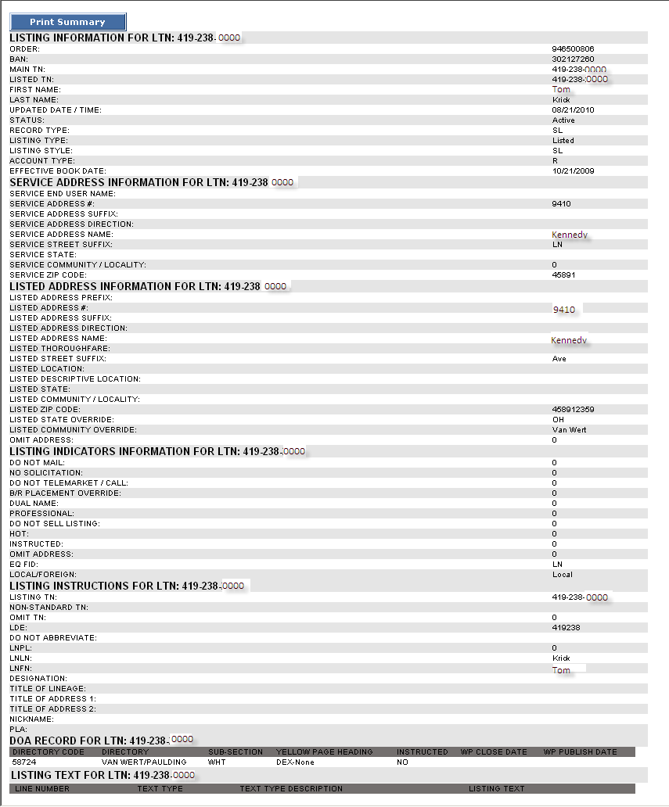

Additional Listing Details, Continued

|  |  |
| --- | --- |
| Additional information by style link | Only certain style codes that have text associated to them such as a CI style will contain a link to additional information.  When the CI link is available and clicked - a new window will open with another link beneath the Caption Text.  **Example:**  Clicking on the **Caption Text** link opens a new window that provides the complete caption listing details. From this screen you can print or save the caption information.  **Example** |